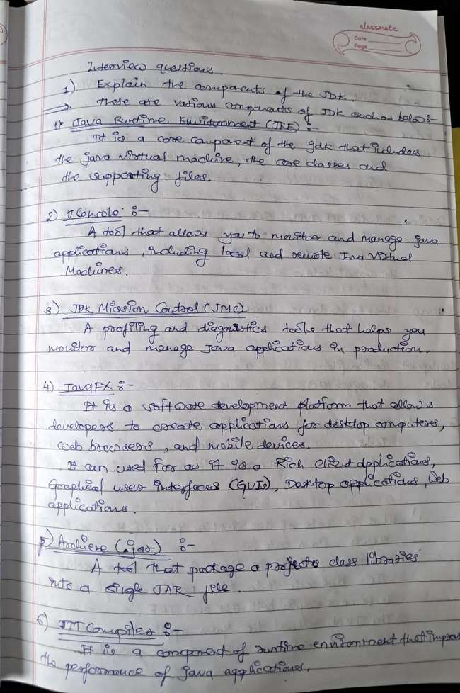

1. Explain the components of the JDK.

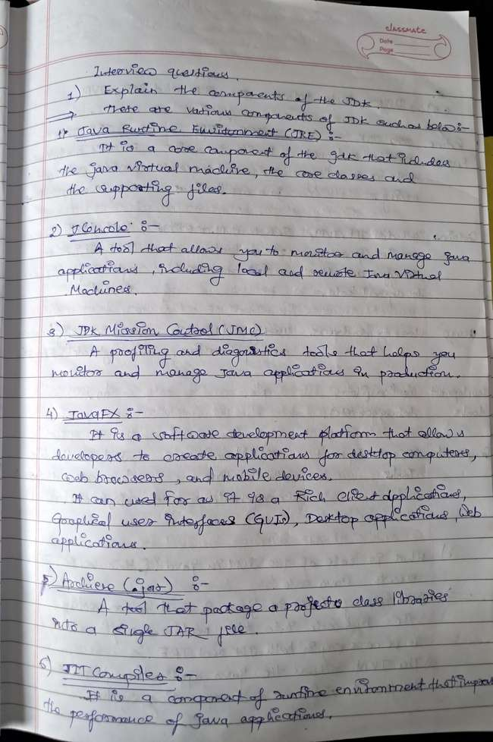

1. Differentiate between JDK, JVM, and JRE.

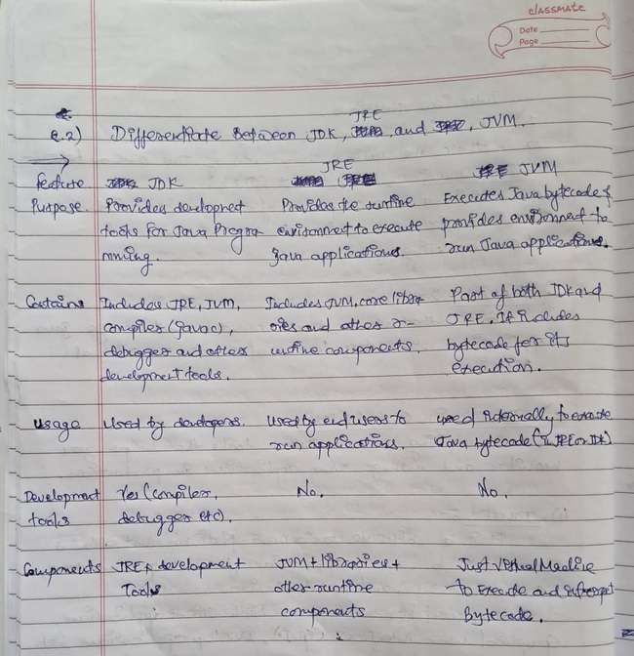

1. What is the role of the JVM in Java? & How does the JVM execute Java code?

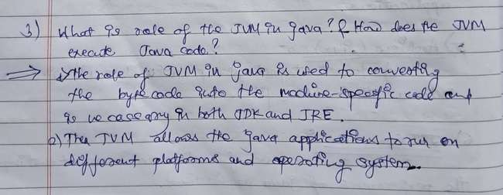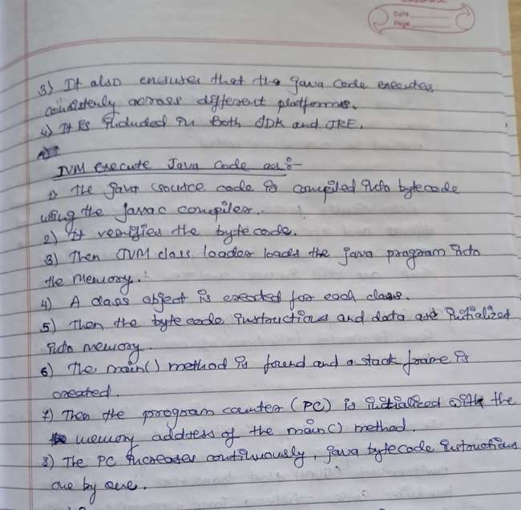

1. Explain the memory management system of the JVM.

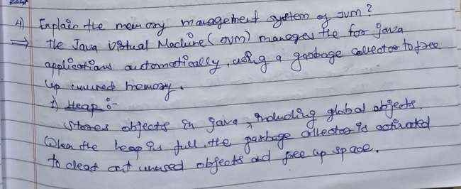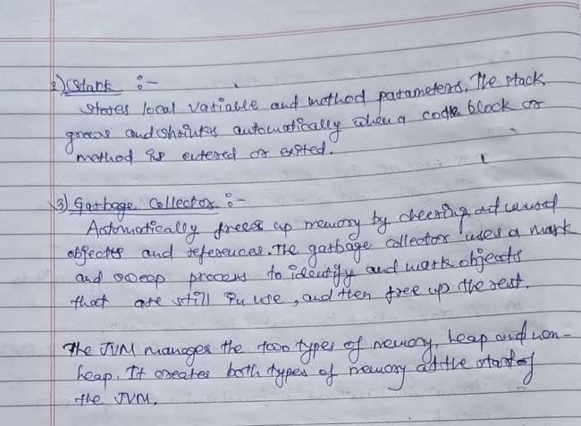

5) What are the JIT compiler and its role in the JVM? What is the bytecode and why is it important for Java?

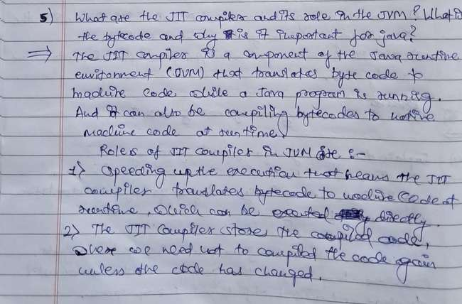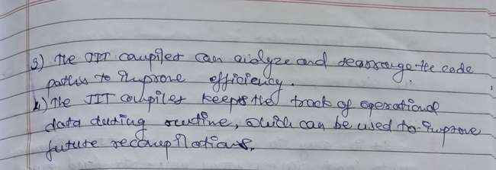

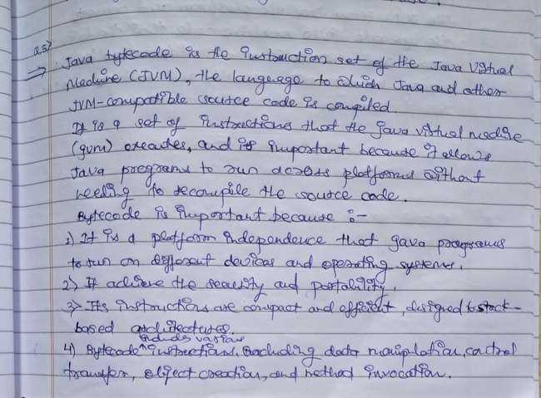

1. Describe the architecture of the JVM.

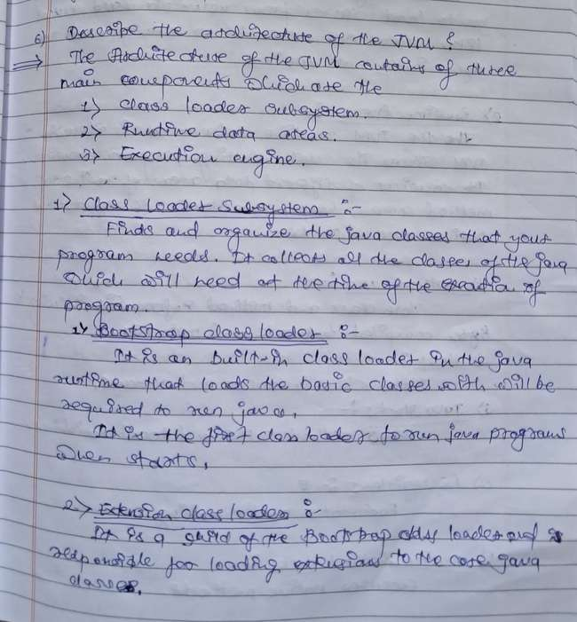

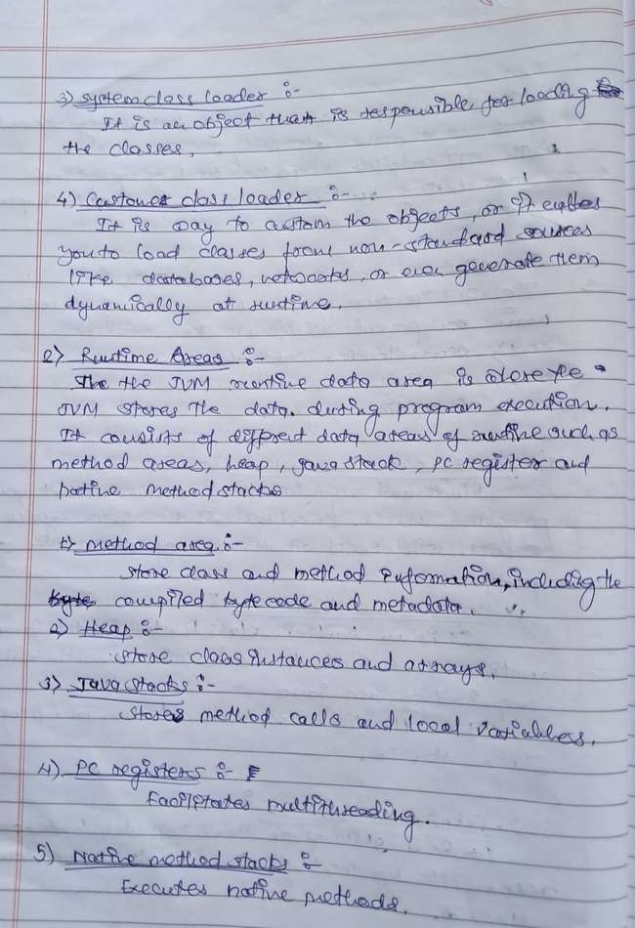

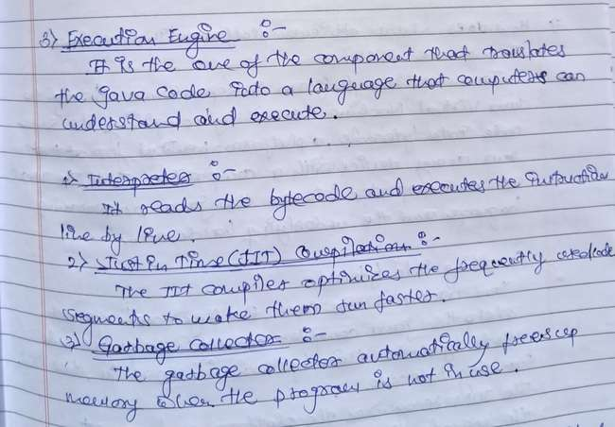

1. How does Java achieve platform independence through the JVM?

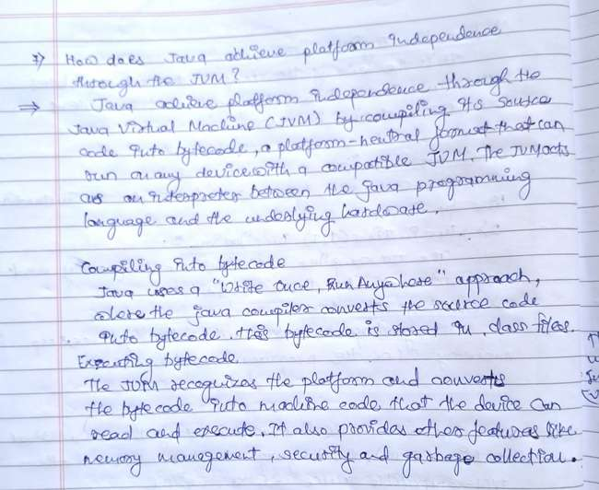

1. What is the significance of the class loader in Java? What is the process of garbage collection in Java.?

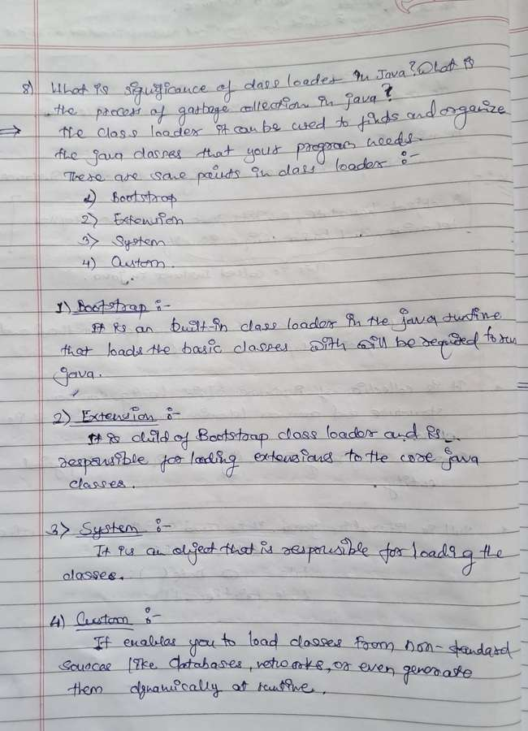

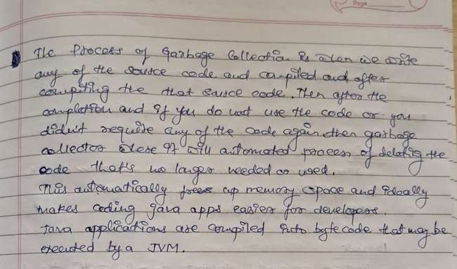

9) What are the four access modifiers in Java, and how do they differ from each other?

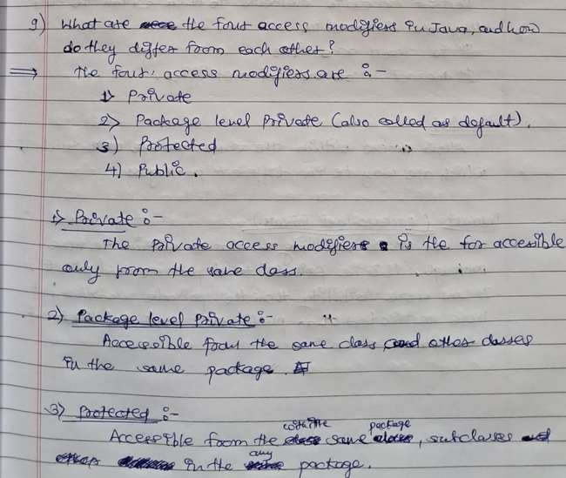

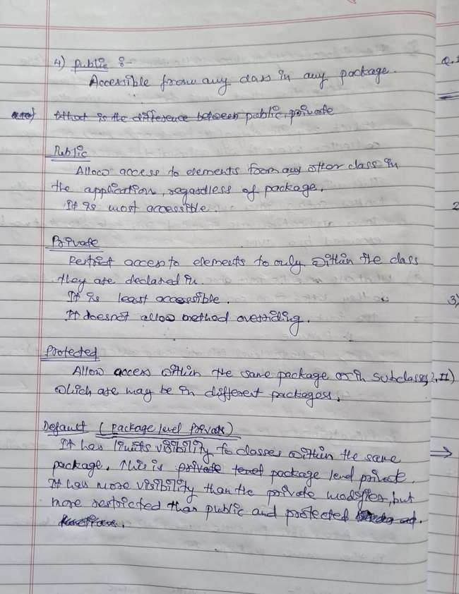

10) What is the difference between public, protected, and default access modifiers?

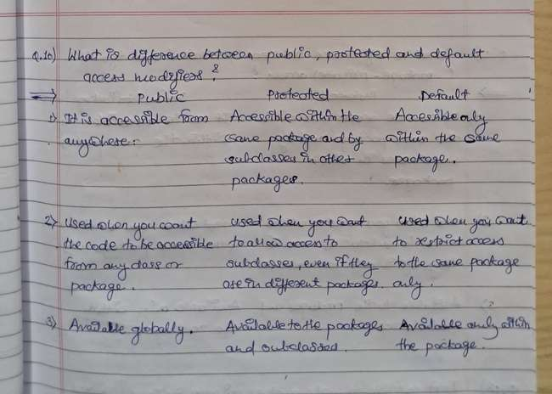

11) Can you override a method with a different access modifier in a subclass? For example, can a protected method in a superclass be overridden with a private method in a subclass? Explain.

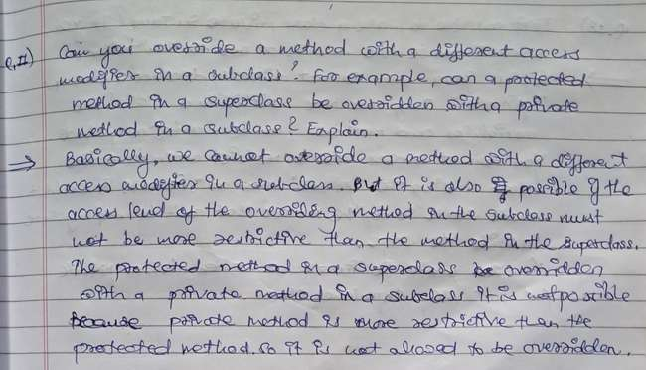

12)What is the difference between protected and default (package-private) access?

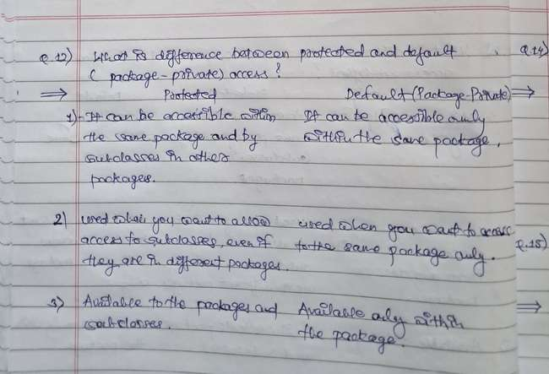

13) Is it possible to make a class private in Java? If yes, where can it be done, and what are the limitations?

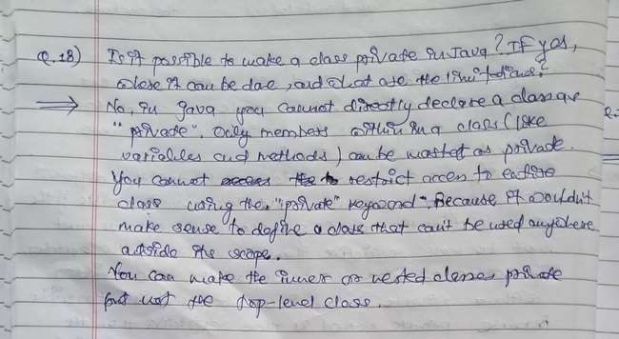

14) Can a top-level class in Java be declared as protected or private? Why or why not?

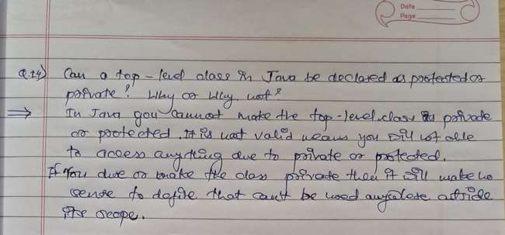

15) What happens if you declare a variable or method as private in a class and try to access it from another class within the same package?

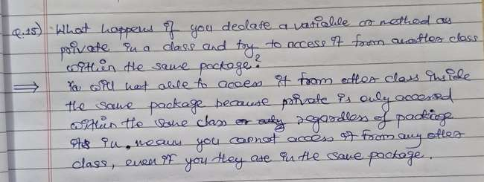

16) Explain the concept of "package-private" or "default" access. How does it affect the visibility of class members?

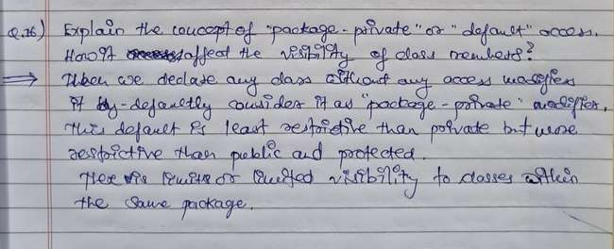

13) Is it possible to make a class private in Java? If yes, where can it be done, and what are the limitations?

